Master Thesis Description

Background:
The robotic assembly project is rooted in the need for increased efficiency, accuracy, and safety in the manufacturing industry. Assembly work, which involves putting various components together to create a finished product, can be labor-intensive and prone to errors. These issues can lead to decreased productivity, increased costs, and a higher risk of injury to workers. In order to address these challenges, the use of robotic arms in assembly work has become increasingly popular, for example pick and place the components (see Fig. 1 and Fig. 2 [1]).

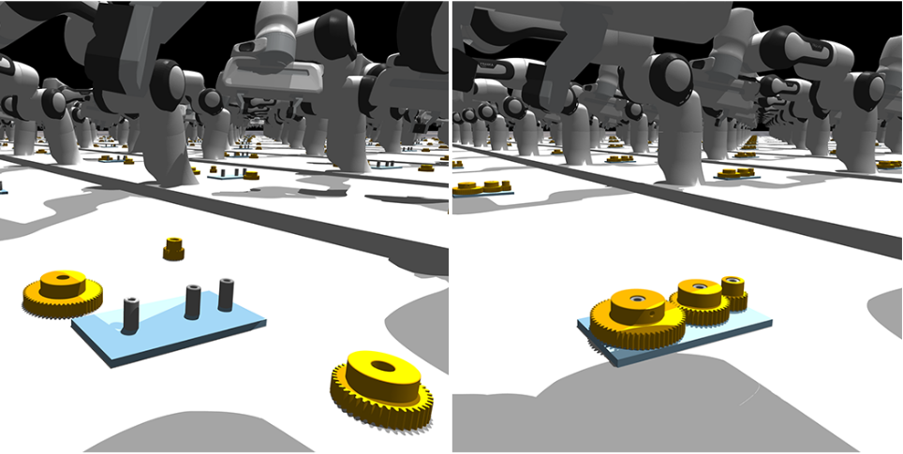
Fig 1. Pick and place the gears task

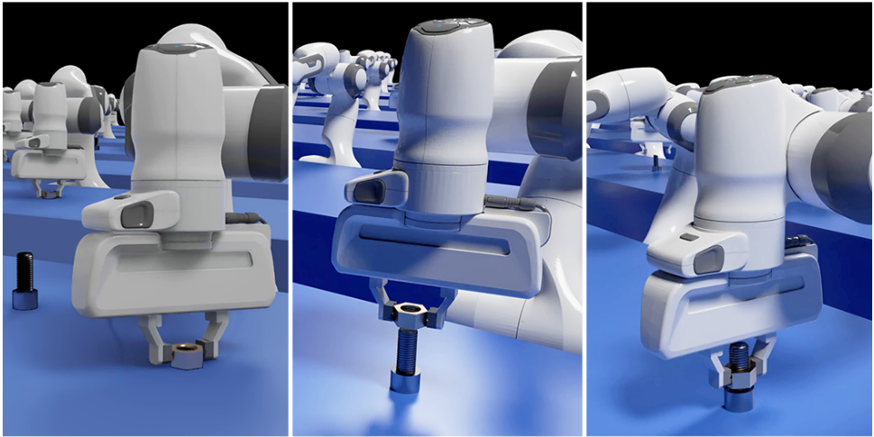
Fig 2. Pick and place the screw task

Objectives:

- Design the accurate CAD files such as 6-DoF robotic arm, task board, and components accordingly with the actual needs;
- Implement the proper and stable controller for robotic arm manipulation;
- Learn to pick and assemble with a state-of-the-art reinforcement learning (RL) algorithm and test an assembling policy in Isaac Sim;

Schedule:

 | February | March | April | May | June | July
Search for SOTA related work
Design CAD files and model in Issac
Implement Controllers
Train the RL policy
Write the dissertation
Master defense

Reference:
[1]. Y. Narang, K. Storey, I. Akinola, M. Macklin, P. Reist, L. Wawrzyniak, Y. Guo, A. Moravanszky, G. State, M. Lu, et al., “Factory: Fast contact for robotic assembly,” arXiv preprint arXiv:2205.03532, 2022.45

